

K.L.E. SOCIETY’S
P.C. JABIN SCIENCE COLLEGE,
AUTONOMUS,
(Affiliated to KARNATAK UNIVERSITY, DHARWAD)
HUBBALLI -580031
Bachelor of Computer Application
2025-26

A Dissertation Report
On

JeevanSetu - Real Time Blood & Plasma Donar App
Submitted in partial fulfillment of the requirement for the award of the degree

BACHELOR OF COMPUTER APPLICATION

Submitted By

Madhav P Amruth Badi Guruprasad Charati
223204 223183 223196

Under The Guidance Of Prof. POORNIMA N. H.

Affiliated to
Karnatak University, Dharwad.

CERTIFICATE

This is to certify that the project entitled JeevanSetu is a Bonafide work carried out by the student team Mr. Madhav P – Reg No 223204 and Mr. Amruth Badi -Reg No 223183, Mr. Guruprasad Charati - Reg No 223186 in partial fulfillment of the award of degree of Bachelor of Computer Application during the year 2025 – 2026. The project report has been approved as it satisfies the academic requirement with respect to the project work prescribed for the award of BCA Degree.

__________________ _____________
Guide HOD

External Examination:

Name of the Examiners Signature with date
1.

2.

DECLARATION

We hereby declared that the project report entitled JeevanSetu, submitted in fulfillment of requirement of BCA V Semester Project work for the award of Degree in Bachelor of Computer Application of KARNATAK UNIVERSITY, Dharwad during the academic year 2025-26.
We further declare that this project report is the result of our original work and has not been submitted to any other organization or institute for the award of any degree or diploma.

Date: 15/12/2025
Place: Hubballi

Sign (Amruth Badi)

Sign(Guruprasad Charati)

Sign(Madhav P)

ACKNOWLEDGEMENT

It’s our pleasure to thank all the individuals who have directly or indirectly helped and motivated us in the fulfilment of completion of the project work.
We thank Prof. Siddalingappa Kadakol, HOD, KLE Society’s BCA, P C Jabin Science College, HUBBALLI for having given us all encouragement and motivation for making this project work successful.
We thank our guide Prof. Poornima N. H., KLE Society’s BCA, P C Jabin Science College, HUBBALLI for giving us valuable suggestions and guidance for our project work, which are the background of the project.
Our gratitude also goes to all Teaching and Non-Teaching staff of KLE Society’s BCA, P C Jabin Science College, HUBBALLI who have helped us in completing this project work.
Finally, we would like to thank our family and friends for their constant motivation and inspiration that kept us going.

Sign (Amruth Badi)

Sign(Guruprasad Charati)

Sign(Madhav P)

ABSTRACT

JeevanSetu is a dedicated MERN-stack application designed to bridge the gap between blood/plasma donors and recipients in real-time. In critical medical emergencies, finding a compatible donor often becomes a chaotic and time-sensitive challenge. JeevanSetu addresses this by providing a unified platform where donors and recipients can register, manage profiles, and connect efficiently.

The application allows users to register as either a Donor or a Recipient . Recipents can post detailed requests for blood or plasma, specifying urgency, blood group, and location. Donors, on the other hand, have access to a dashboard that matches them with compatible requests in their vicinity. The system features a secure JWT-based authentication mechanism, ensuring data privacy and integrity.

Key features include :-

Role-Based Workflows :- Distinct interfaces for donors and recipients to streamline their specific tasks.
Real-Time Matching :- Algorithm to surface relevant requests to donors based on blood group and location compatibility.
Donation History :- Automatic logging of donations when requests are fulfilled, creating a verifiable track record for donors.
Status Tracking :- Comprehensive status updates for requests (Open, Matched, Fulfilled, Cancelled) to keep all parties informed.

Built with MongoDB, Express.js, React.js, and Node.js , JeevanSetu leverages modern web technologies to ensure scalability, responsiveness, and a user-friendly experience. This project aims to digitize and optimize the humanitarian act of blood donation, potentially saving lives by reducing the time taken to find a donor.

CONTENTS

Slno Topic Page No
- Introduction 1
- Literature Survey 4
- Technical Requirements 7
- Project Description 9
- System Design ¹²
- UI Design And Outputs ¹⁷
- Implementation ¹⁹
- Test Case ³⁷
- Conclusion ⁴³
10. Future Enhancement 44
11. Bibliography ⁴⁵

I. Introduction

The healthcare sector has always been a critical domain where timeliness and efficiency can determine the difference between life and death. One of the most persistent challenges in medical emergencies is the timely availability of blood and plasma. Despite numerous awareness campaigns and voluntary donation drives, the connection between a willing donor and a patient in need remains fragmented and often reliant on manual, disorganized methods.

JeevanSetu – Real-Time Blood & Plasma Donor App is a digital initiative designed to solving this logistical bottleneck. It acts as a digital bridge ("Setu") between those who give ("Jeevan" - Life) and those who are in need. By leveraging modern web technologies, specifically the MERN stack (MongoDB, Express, React, Node.js), the application provides a centralized, accessible, and efficient platform for managing blood donation requests.

In many traditional scenarios, when a patient requires blood, family members are forced to frantically call friends, post on social media, or rely on limited hospital databases. This process is stressful, time-consuming, and unfortunately, not always successful. JeevanSetu automates this discovery process. A recipient can simply log a request with the necessary medical details, and the system instantly makes this visible to compatible, registered donors.

The project encompasses a full-stack web application that handles user registration, secure authentication, request lifecycle management, and historical record-keeping of donations. It is designed not just as a technical demonstration, but as a potential tool for social good, emphasizing user experience, data security, and operational reliability.

Background and Motivation

Blood is a vital resource that cannot be manufactured artificially. According to the World Health Organization (WHO), an adequate and safe blood supply is essential for any healthcare system. India requires approximately 12-15 million units of blood annually, but only about 11 million units are collected, leaving a significant shortfall of 3-4 million units every year. This deficit directly impacts surgical procedures, accident victims, cancer patients, and those with blood disorders like thalassemia and hemophilia.

The situation becomes even more critical during emergencies. When a patient urgently needs blood:

* Family members panic and start making frantic phone calls
* Social media posts are shared widely, often reaching irrelevant audiences
* Valuable time is lost in verifying donor availability and blood group compatibility
* There is no systematic way to track who responded or whether the need was fulfilled

This gap between willing donors and patients in need is not due to a lack of generosity but rather a lack of **connectivity infrastructure**. Studies show that many willing donors simply don't know when and where their help is needed most.

How JeevanSetu Works

In many traditional scenarios, when a patient requires blood, family members are forced to frantically call friends, post on social media, or rely on limited hospital databases. This process is stressful, time-consuming, and unfortunately, not always successful. JeevanSetu automates this discovery process. A recipient can simply log a request with the necessary medical details, and the system instantly makes this visible to compatible, registered donors.

The workflow is simple yet powerful:
1. Recipients post detailed blood requests with patient information, hospital location, and urgency level
2. Donors receive notifications or view matching requests on their personalized dashboard
3. Smart Matching ensures only compatible donors (based on blood group and location) see relevant requests
4. Status Tracking keeps all parties informed as the request progresses through its lifecycle
5. History Logging creates permanent records for both donors and recipients

Limitations of existing system

- Fragmentation :- Information is scattered across various hospitals, blood banks, and informal social media groups, making it difficult to find a consolidated list of donors.
- Time Latency :- Manual calling lists or waiting for social media responses introduces critical delays during emergencies.
- Lack of Privacy :- Donors' contact information is often shared publicly on social media, leading to potential privacy concerns.
- Unverified Data :- Social media posts often circulate long after the requirement is fulfilled, leading to confusion and wasted effort for willing donors.
- No History Tracking :- Informal donations often go unrecorded, meaning donors don't have a personal record of their contributions, and the system cannot track frequent donors for health safety.
- Geographical Mismatch :- Finding a donor who is physically near the patient is often a matter of luck rather than a systematic search.

II. Literature Survey
A feasibility study examines the practicality and viability of developing an JeevanSetu - Real - Time Blood & Plasma Donar App by evaluating whether the system can be successfully implemented using available tools, technologies, and resources. A comprehensive feasibility study was conducted to evaluate the viability of developing JeevanSetu. The study focused on Technical, Economic, and Operational feasibility to ensure the project could be successfully delivered within the academic timeframe and resource constraints.

Objectives of the Project

- Centralized Platform :- To create a single, unified database of voluntary blood and plasma donors.
- Real-Time Connection :- To reduce the turnaround time for finding a donor by instantly notifying or displaying requests to relevant users.
- Data Integrity :- To maintain accurate records of donors, recipients, and the history of donations to prevent fraud and ensure medical safety limits (e.g., time between donations).
- User Privacy :- To securely handle personal information like phone numbers and addresses, revealing them only when necessary or authorized.

- Accessibility :- To provide a responsive web interface that works seamlessly on both desktop and mobile devices, ensuring access from anywhere.
- Process Transparency :- To track the status of a request from "Open" to "Matched" to "Fulfilled", giving peace of mind to the recipient and clarity to the donor.

Economic Feasibility
JeevanSetu is designed to be cost-effective.

- Open Source :- All core technologies (Node, React, Mongo) are open-source and free to use.
- Hosting :- The application can be deployed on free tiers of modern cloud platforms (e.g., Vercel for frontend, Render/Railway for backend, MongoDB Atlas for database) for testing and small-scale operation.
- Maintenance :- The codebase uses standard patterns, reducing the cost and effort required for future maintenance or upgrades.

Technical Feasibility
The project aims to build a real-time responsive web application. The MERN stack was chosen for its ubiquity and robust ecosystem.

- MongoDB :- A NoSQL database is ideal for the flexible schema required for user profiles and varied request details. It handles JSON-like documents, which maps directly to the objects used in the application code.
- Express.js & Node.js :- These provide a lightweight, event-driven backend capable of handling multiple concurrent requests, which is essential for a platform that might experience spikes in traffic during emergencies.

- React.js :- A component-based frontend library ensures a reactive user interface. State management in React allows for immediate feedback to users (e.g., when a request is matched or a status changes) without full page reloads.
- JWT (JSON Web Tokens) :- For stateless authentication, ensuring that user sessions are secure and scalable.

Organizational Feasibility
The system is designed with a user-centric approach. The interface is intuitive, requiring minimal training for users.
- Donors :- Can easily toggle availability and view requests.
- Recipients :- Can post requests via a simple form.
The workflow mimics standard interactions users are already familiar with in other apps (forms, lists, status updates), ensuring high operational acceptance.

III. Technical Requirements
Hardware Requirements :-
- Processor :- Intel Core i3 or higher / AMD Ryzen 3 or higher.
- RAM :- 4GB (8GB recommended for optimal development experience).
- Storage :- 20 GB free space (SSD recommended for faster compilation).
- Internet :- Stable internet connection for package installation and cloud database connectivity.
Software Requirements :-
- Operating System :- Windows 10/11, macOS, or Linux.
- Runtime Environment :- Node.js (Latest LTS version).
- Database :- MongoDB (Local instance or MongoDB Atlas Cloud).
- Code Editor :- Visual Studio Code (VS Code).
- Version Control :- Git.
- API Testing :- Postman or Thunder Client.
- Browser :- Google Chrome (with React Developer Tools) or Microsoft Edge.
Technologies Used :-
Frontend Library :- React.js (Vite build tool)
CSS Framework :- Tailwind CSS (for rapid, utility-first styling)
State Management :- React Hooks (useState, useEffect, useContext)
Routing :- React Router DOM
HTTP Client :- Axios
Backend Framework :- Express.js
ODM :- Mongoose
Authentication :- JSON Web Tokens (Access + Refresh tokens)
Password Hashing :- Bcrypt

IV. Project Description

JeevanSetu is a comprehensive solution designed to manage the lifecycle of a blood donation request. The application logic is divided into two primary roles :- Donor and Recipient.

Core Modules
1. Authentication & Authorization Module :-

- Secure registration and login.
- Role selection (Donor/Recipient) during sign-up.
- JWT-based session management with HttpOnly cookies for security.

2. Profile Management Module :-
- Users can manage their personal details, including blood group, location (Country, State, City), and contact information.
- Donors have a special "Availability" toggle to indicate if they are currently ready to donate.

3. Request Management Module (Recipient) :-
- Recipients can create new requests specifying :- Patient Name, Hospital, Blood Group, Quantity, Urgency Level, and Location.
Requests have a lifecycle: `Open` -> `Matched` -> `Fulfilled` (or `Cancelled`).
- Recipients can view the status of their active requests.
4. Donor Matching Module :-
- This is the core intelligence of the system.

- Donors do not see every request; they see a filtered feed of "Compatible" requests.
- Compatibility is determined by Blood Group matching logic (e.g., O- donor can help everyone, A+ donor can help A+ and AB+ recipients) and Location availability.
5. Donation Execution Module :-
- When a donor "accepts" or matches a request, the status updates to `Matched`.
- Contact details are shared to coordinate the Donation.
- Once the donation is complete, the recipient marks it as `Fulfilled`.

6. History & Analytics :-

- The system automatically generates a "Donation Record" when a request is fulfilled.
- Donors can view their entire donation history (Date, Location, Quantity).
- The system tracks the `lastDonationAt` date to ensuring donors don't donate too frequently (though strict medical enforcing is manual, the data is available).

Functional Workflow

1. Registration :- A user signs up. If they are a generic user, they select a role.
2. Emergency :- A Recipient creates a request: "Need A+ Blood at KIMS Hospital by Tomorrow."
3. Discovery :- Donor 'Arjun' (A+) logs in. The system identifies him as compatible. He sees the request on his dashboard.
4. Action :- Arjun clicks "Donate". The request status changes to `Matched`. The recipient sees that Arjun has volunteered.
5. Completion :- They meet at the hospital. The donation occurs. The recipient clicks "Mark as Fulfilled".
6. Record :- A permanent record is added to Arjun's profile: "Donated 1 Unit of A+ Blood on [Date]".

This structured flow ensures organization, accountability, and speed, which are lacking in ad-hoc social media requests.

V. System Design
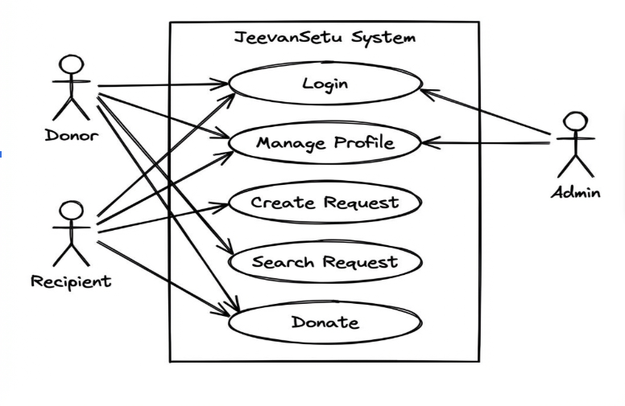
- UML Diagrams of the project modules

Actors Identified
- The system has three primary actors — Donor (users who volunteer to donate blood), Recipient (users who need blood/plasma for patients), and Admin (system administrator who manages the platform).

Login Use Case
- All three actors (Donor, Recipient, Admin) can access the Login functionality. This is the entry point to the system, using JWT-based authentication for secure session management.

Manage Profile Use Case
- Both Donor and Recipient can manage their profiles. This includes updating personal information like name, contact details, blood group, and location. Donors can also toggle their availability status here.

Create Request Use Case
- Only the Recipient actor can create blood/plasma requests. This use case allows them to specify patient details, required blood group, hospital name, urgency level, and location.

Search Request Use Case
- The Donor actor can search and view compatible blood requests. The system filters requests based on the donor's blood group and location to show only relevant matches.

Donate Use Case
- When a Donor finds a compatible request, they can initiate the Donate action. This matches them with the request, updates the status to "Matched", and shares contact details with the Recipient.

Admin Oversight
- The Admin actor has access to Manage Profile and Search Request for monitoring purposes. This allows administrators to view system activity, manage user accounts, and ensure platform integrity.

- Architectural Diagram of a project
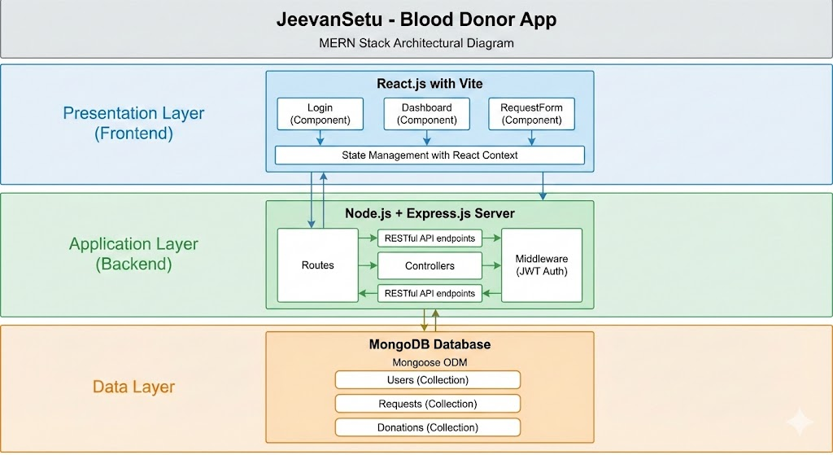

The system follows the Model-View-Controller (MVC) architectural pattern adapted for the REST API structure.

1. Presentation Layer (Frontend) :-
- Built with React.js.
- Responsible for rendering the UI and capturing user input.
2. Application Logic Layer (Backend) :-
- Built with Node.js and Express.js.

- Handles API routing, business logic, and authentication.
3. Data Layer (Database) :-
- MongoDB stores data as JSON-like documents.

3. ER Diagram of Database Design

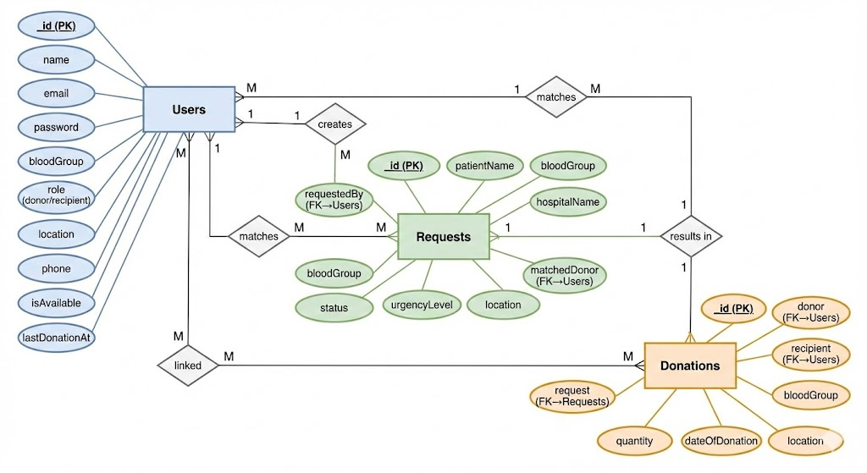

Entities & Relationships :-

Users Entity
- The central entity storing all registered users (both donors and recipients). Key attributes include _id (Primary Key), name, email, password (hashed), bloodGroup, role (donor/recipient), location, phone, isAvailable (for donors), and lastDonationAt timestamp.

Requests Entity
- Represents blood/plasma donation requests created by recipients. Contains _id (PK), patientName, bloodGroup, hospitalName, urgencyLevel, status (open/matched/fulfilled), location, and two foreign keys: requestedBy (links to the user who created it) and matchedDonor (links to the donor who accepted).

Donations Entity
- Records completed donation transactions. Includes _id (PK), bloodGroup, quantity, dateOfDonation, location, and three foreign keys: donor (FK→Users), recipient (FK→Users), and request (FK→Requests)

Relationships

Users ↔ Requests (creates)
- A One-to-Many relationship. One recipient can create multiple requests, but each request belongs to only one requester.

Users ↔ Requests (matches)
- A Many-to-Many relationship. One donor can match multiple requests, and one request can potentially be matched by multiple donors (though the system assigns one final matchedDonor).

Requests ↔ Donations (results in)

- A One-to-One relationship. Each fulfilled request generates exactly one donation record to log the completed transaction.

Users ↔ Donations (linked)
- A Many-to-Many relationship. Users participate in donations as either donors or recipients. This allows tracking of donation history for both parties.

VI . User Interface Design and Outputs

Main page :-

File Name :- Home.jsx

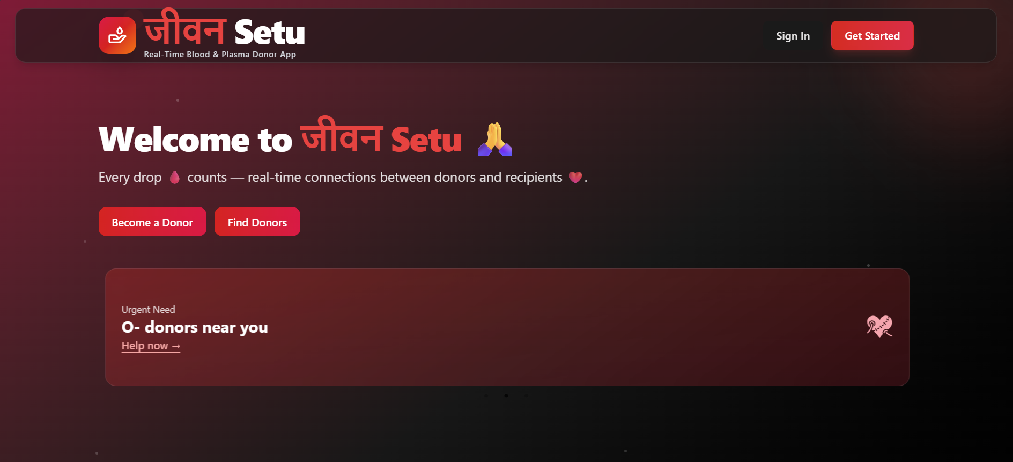

Login Page :--
File name :- (Login.jsx)

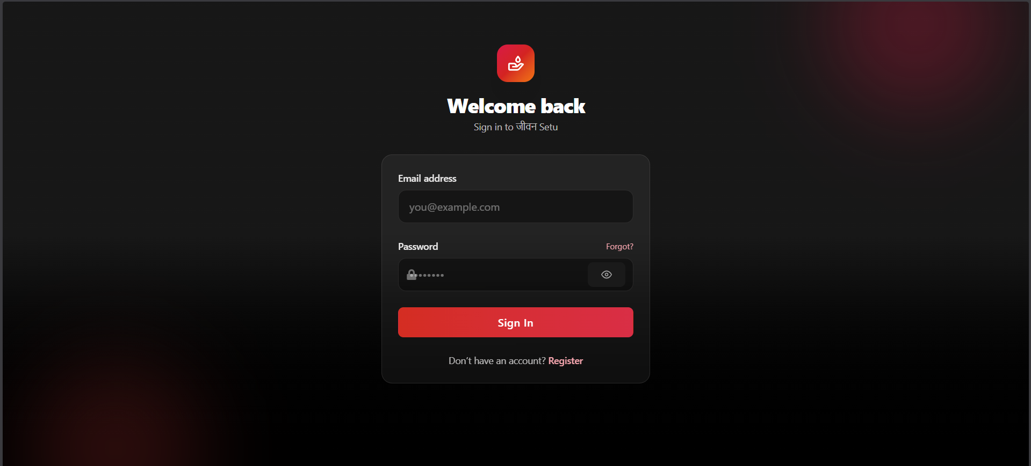

VII. Implementation (Deployment)
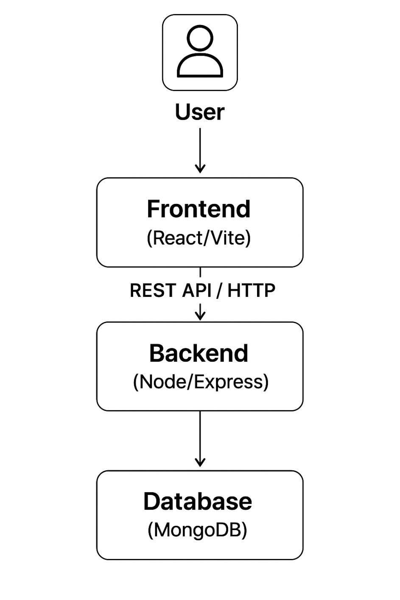

Steps to Deploy the Application in User Environment :-
This chapter details the core code structure that powers JeevanSetu.

Backend Implementation :-
1. Project Structure
```
jeevansetu-backend/
├── src/
│ ├── config/
│ │ └── db.js # Database connection
│ ├── controllers/
│ │ ├── authController.js # Authentication logic
│ │ ├── requestController.js # Blood request handling
│ │ └── donationController.js # Donation management
│ ├── middleware/
│ │ ├── authMiddleware.js # JWT verification
│ │ └── errorHandler.js # Global error handling
│ ├── models/
│ │ ├── User.js # User schema
│ │ ├── Request.js # Request schema
│ │ └── Donation.js # Donation schema
│ ├── routes/
│ │ ├── authRoutes.js # /api/auth endpoints

│ │ ├── requestRoutes.js # /api/requests endpoints
│ │ └── donationRoutes.js # /api/donations endpoints
│ └── utils/
│ └── generateToken.js # JWT token generation
├── server.js # Application entry point
└── package.json
```

1. Architectural Pattern
The backend follows the MVC (Model-View-Controller) pattern, adapted for RESTful API development:
Models: Define the data structure and business rules using Mongoose schemas
Controllers: Contain the business logic for processing requests
Routes: Map HTTP endpoints to controller functions
Middleware: Handle cross-cutting concerns like authentication and error handling
This separation of concerns makes the codebase maintainable, testable, and scalable.

2. Database Layer
MongoDB was chosen as the database for several reasons:
Flexible Schema: Blood donation requests can have varying fields based on urgency and requirements

JSON-like Documents: Natural fit with JavaScript/Node.js ecosystem
Scalability: Easy horizontal scaling as the user base grows
Rich Query Capabilities: Support for complex filtering (blood group, location, status)

Mongoose ODM provides:
Schema validation to ensure data integrity
Middleware hooks for operations like password hashing
Population for handling relationships between collections
Built-in validation for required fields and data types

3. Authentication and Security
Security is paramount in a healthcare-related application. The following measures were implemented:
Password Security:
Passwords are never stored in plain text
Bcrypt hashing algorithm with salt is used before storage
Even database administrators cannot view user passwords

Minimum password length enforced at both frontend and backend

JWT (JSON Web Token) Authentication:
Stateless authentication mechanism
Tokens contain encrypted user information
HttpOnly cookies prevent XSS attacks
7-day expiration with automatic renewal
Tokens are verified on every protected route access

Role-Based Access Control:
Users are assigned roles (Donor/Recipient) during registration
Middleware checks user roles before allowing certain actions
Recipients cannot access donor-only features and vice versa
Prevents unauthorized data access and manipulation

Data Validation:
Dual-layer validation (frontend + backend)
Email format validation using regex patterns

Phone number validation for Indian mobile numbers
Blood group restricted to valid values (A+, B+, O+, AB+, A-, B-, O-, AB-)

Input sanitization to prevent injection attacks

4. API Design
The backend exposes a RESTful API with clear, intuitive endpoints:
Authentication Endpoints:
User registration with role selection
Login with credential verification
Logout with token invalidation
Current user profile retrieval

Request Management Endpoints:
Create new blood requests (Recipient only)
View all compatible requests (Donor only)
Match with a request (Donor only)
Update request status (Recipient only)
Cancel requests (Recipient only)
Donation History Endpoints:
View personal donation history
Retrieve donation statistics
Generate donation certificates

All endpoints follow consistent patterns:
POST for creating resources
GET for retrieving data
PUT/PATCH for updates
DELETE for removal
Proper HTTP status codes (200, 201, 400, 401, 403, 404, 500)

5. Blood Group Matching Logic
One of the core features is the intelligent matching algorithm:
Compatibility Rules:
O- donors can donate to anyone (Universal Donor)
AB+ recipients can receive from anyone (Universal Recipient)
Same blood group always compatible
Rh-negative can donate to Rh-positive of same ABO group

Complex compatibility matrix implemented for all 8 blood groups

Filtering Mechanism:
Donors only see requests matching their blood group compatibility
Location-based filtering (same city/state)
Urgency-based sorting (critical requests shown first)
Status filtering (only open requests displayed)
Database indexes on blood group and location for fast queries

6. Error Handling
Robust error handling ensures smooth user experience:
Validation Errors: Clear messages for invalid inputs
Authentication Errors: Proper 401 responses for unauthorized access
Database Errors: Graceful handling of connection issues
Server Errors: Generic messages to users, detailed logs for developers
Global Error Handler: Catches all unhandled exceptions

Frontend Implementation :-
1. Project Structure :-
```
jeevansetu-frontend/
├── src/
│ ├── components/
│ │ ├── common/
│ │ │ ├── Navbar.jsx
│ │ │ ├── Footer.jsx
│ │ │ └── Loader.jsx
│ │ ├── auth/
│ │ │ ├── LoginForm.jsx
│ │ │ └── RegisterForm.jsx
│ │ ├── dashboard/
│ │ │ ├── DonorDashboard.jsx
│ │ │ └── RecipientDashboard.jsx
│ │ └── requests/
│ │ ├── RequestCard.jsx
│ │ ├── RequestList.jsx
│ │ └── CreateRequestForm.jsx
│ ├── context/
│ │ └── AuthContext.jsx
│ ├── hooks/
│ │ └── useAuth.js
│ ├── pages/
│ │ ├── Home.jsx
│ │ ├── Login.jsx
│ │ ├── Register.jsx
│ │ ├── Dashboard.jsx
│ │ └── DonationHistory.jsx
│ ├── services/
│ │ └── api.js
│ ├── App.jsx
│ └── main.jsx
├── index.html
├── tailwind.config.js
└── package.json
```

1. Technology Choices

React.js
Component-based architecture for reusable UI elements

Virtual DOM for efficient rendering
Hooks for state management without class components
Large ecosystem of libraries and tools

Vite:
Lightning-fast development server with Hot Module Replacement (HMR)
Optimized production builds
Modern ES modules support
Significantly faster than traditional bundlers like Webpack

Tailwind CSS:
Utility-first CSS framework
Rapid UI development without writing custom CSS
Consistent design system
Responsive design with built-in breakpoints
Small production bundle size with purging

Axios:
Promise-based HTTP client
Automatic JSON transformation

Request/response interceptors for global handling
Better error handling than fetch API
Configured with base URL and credentials

2. Component Architecture
The frontend is organized into logical component categories:

Page Components:
Full-page views like Home, Login, Register, Dashboard
Handle routing and layout structure
Compose smaller components into complete interfaces

Feature Components:
Request-specific components (RequestCard, RequestList, CreateRequestForm)
Dashboard components (DonorDashboard, RecipientDashboard)
Authentication forms (LoginForm, RegisterForm)

Common Components:
Reusable elements like Navbar, Footer, Loader, Button
Consistent styling across the application
Reduced code duplication
Context Providers:
AuthContext manages global authentication state
Provides user information to all components
Handles login, logout, and session persistence

3. State Management
React Context API is used for global state management:

Authentication State:
Current logged-in user information
Loading states during authentication checks
Login/logout functions available globally
Automatic redirection for unauthenticated users

Local Component State:
Form inputs managed with useState hook
Loading indicators during API calls
Error messages for user feedback
UI state like modals, dropdowns, toggles
4. Routing and Navigation
React Router DOM handles client-side routing:
Public Routes:
Landing page accessible to all
Login and registration pages
About and contact pages

Protected Routes:
Dashboard (requires authentication)
Donation history (requires authentication)
Profile management (requires authentication)
Automatic redirect to login if not authenticated

Route Guards:
ProtectedRoute component wraps authenticated pages
Checks authentication status before rendering
Shows loading spinner during verification
Redirects to login if no valid session

5. User Experience Features
Responsive Design:
Mobile-first approach using Tailwind breakpoints
Adapts to screen sizes from 320px to 4K displays
Touch-friendly interface elements
Optimized for both desktop and mobile usage

Loading States:
Skeleton screens during data fetching
Button loading indicators during form submission
Global loading overlay for page transitions
Prevents duplicate submissions

Error Handling:
User-friendly error messages
Form validation feedback in real-time
Network error notifications
Retry mechanisms for failed requests

Accessibility:
Semantic HTML elements
ARIA labels for screen readers
Keyboard navigation support
Sufficient color contrast ratios

6. API Integration
The frontend communicates with the backend through a centralized API service:
Request Interceptors:
Automatically attach authentication tokens
Add common headers to all requests
Log requests for debugging

Response Interceptors:
Handle authentication errors globally
Transform response data
Catch network errors
Redirect to login on 401 errors

Error Handling:
Display user-friendly error messages
Log detailed errors for debugging
Retry failed requests when appropriate
Offline detection and notification

Integration and Data Flow
Complete Request Lifecycle

1. Request Creation:
- Recipient fills out request form on frontend
- Form validation ensures all required fields are present
- Frontend sends POST request to `/api/requests`
- Backend validates data and checks user role
- Request saved to MongoDB with status "Open"
- Recipient sees confirmation and request appears in their list

2. Donor Discovery:
- Donor logs in and navigates to dashboard
- Frontend requests compatible requests from backend
- Backend queries database with blood group and location filters
- Only compatible, open requests are returned
- Frontend displays requests sorted by urgency

3. Matching:
- Donor clicks "Donate" on a request
- Frontend sends POST to `/api/requests/:id/match`
- Backend verifies donor eligibility
- Request status updated to "Matched"
- Donor ID added to request
- Both donor and recipient see updated status

4. Completion:
- After donation, recipient marks request as "Fulfilled"
- Backend creates Donation record
- Updates donor's donation count and last donation date
- Request archived with "Fulfilled" status
- Donation appears in both users' history

Security Throughout
Every step includes security checks:
Authentication verified on every API call
Role permissions checked before actions
Data validated before database operations
Sensitive information only shared after matching
Audit trail maintained for all actions

VIII. Testing methods with test case

Testing is a critical phase in the software development lifecycle that ensures the application functions correctly, securely, and efficiently. For JeevanSetu, a comprehensive testing strategy was employed covering multiple levels of testing.

Testing Methodologies:

1. Unit Testing
Unit testing focuses on testing individual components or functions in isolation to ensure they work as expected.

Backend Unit Tests
Testing Mongoose model validations (required fields, enum constraints)
Testing password hashing functionality
Testing JWT token generation and verification
Testing blood group compatibility logic

Frontend Unit Tests:
Testing form validation functions
Testing utility functions (date formatting, error handling)
Testing individual React components in isolation

Example: Password Hashing Test

```javascript
describe("User Model", () => {
it("should hash password before saving", async () => {
const user = new User({
name: "Test User",
email: "test@example.com",
password: "plaintext123",
bloodGroup: "A+",
phone: "9876543210",

location: { city: "Hubballi", state: "Karnataka" }
});

await user.save();

expect(user.password).not.toBe("plaintext123");
expect(user.password.length).toBeGreaterThan(50); // bcrypt hash length
});
});
```

2. Integration Testing
Integration testing verifies that different modules or services work together correctly.

API Integration Tests:
Testing complete request-response cycles
Testing database interactions through API endpoints
Testing authentication flow (register → login → protected route)

Example: Registration Flow Test
```javascript
describe("Auth API", () => {
it("should register a new user and return token", async () => {
const res = await request(app)
.post("/api/auth/register")
.send({
name: "New Donor",
email: "donor@test.com",
password: "password123",
bloodGroup: "O+",
role: "donor",
phone: "9876543210",
location: { city: "Hubballi", state: "Karnataka" }
});
expect(res.statusCode).toBe(201);
expect(res.body.success).toBe(true);
expect(res.body.user.email).toBe("donor@test.com");
expect(res.headers["set-cookie"]).toBeDefined();
});
});
```

3. System Testing (End-to-End)
System testing validates the complete application flow from the user's perspective.

Test Scenarios:
Complete Donor Journey: Register → Login → View Requests → Donate → View History
Complete Recipient Journey: Register → Login → Create Request → View Status → Mark Fulfilled
Cross-role Interaction: Recipient creates request → Donor matches → Both see updates

4. Security Testing
Security testing ensures the application is protected against common vulnerabilities.

Tests Performed:
Authentication Bypass: Attempted to access protected routes without token
SQL/NoSQL Injection: Tested input fields with malicious queries
XSS Testing: Verified proper sanitization of user inputs
Password Security: Confirmed passwords are hashed, not stored in plaintext
Cookie Security: Verified HttpOnly and Secure flags on authentication cookies

5. Performance Testing
Basic performance testing was conducted to ensure acceptable response times.

Metrics Tested:
API response time under normal load (< 200ms)
Database query optimization (indexed fields)
Frontend initial load time (< 3 seconds)

Test Cases :-

Sl. No . | Test Case Description | Input Data | Expected Result | Actual Result | Status
1 | User Registration | Valid Name, Email, Password, Blood Group | User created, Token generated | User created, Dashboard loads | Pass
2 | Login with Invalid Data | Unregistered Email | Error: "Invalid Credentials" | Error displayed on UI | Pass
3 | Create Request | Patient Name, Hospital, Urgency | Request saved to DB, Status: "Open" | Request appears in "My Requests" | Pass
4 | Donor Matching | Donor (A+) views requests | System shows A+ and AB+ requests | Only compatible requests shown | Pass
5 | Mark Fulfilled | Recipient clicks "Fulfilled" | Status updates to "Fulfilled" | Status updated, History created | Pass
6 | Access Control | Unauthenticated user visits /dashboard | Redirect to Login | Redirects successfully | Pass

Conclusion
The JeevanSetu project successfully demonstrates the power of modern web technologies to address real-world social challenges. By creating a transparent, efficient, and accessible platform, the application minimizes the chaos typically associated with finding emergency medical donors.

The project fulfilled all its primary objectives :-
1. Efficiency :- Automated matching significantly reduces search time.
2. Reliability :- Persistent record-keeping ensures data is not lost.
3. Scalability :- the MERN architecture enables the system to expand from local deployment to a city-wide or nation-wide service.

In conclusion, JeevanSetu is not just a software application; it is a prototype for a digital infrastructure that values human life and community cooperation.

Future Enhancement :-

- Mobile Application :- Developing a React Native version for better access on smartphones with Push Notifications for high-urgency alerts.
- Geolocation Integration:- Using the Google Maps API to calculate the exact distance between Donor and Hospital, and sorting requests by proximity.
- Blood Bank Integration:- Interfacing with hospital inventory systems to auto-update available stock.
- AI-Powered Matching :- Using machine learning to predict high-demand periods (e.g., seasonal outbreaks) and alert donors proactively.

Bibliography

1.React Documentation :- https://react.dev/
2.Node.js & Express References :- https://nodejs.org/en/docs/
3.MongoDB Manual :- https://www.mongodb.com/docs/manual/
4.Mongoose Library :- https://mongoosejs.com/
5.Tailwind CSS :- https://tailwindcss.com/docs/
6.“Full Stack Development with MERN" - O'Reilly Media
7.JSON Web Token Introduction :- https://jwt.io/introduction

